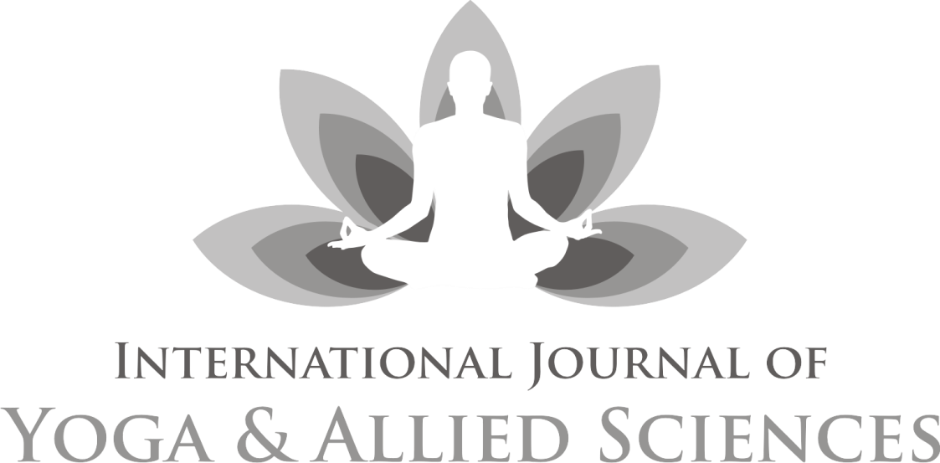

An official publication of Indian Association of Yoga, New Delhi Double-blind, Peer-reviewed, Indexed journal

## Chief Editor

Dr Kamakhya Kumar

**Published by: Indian Association of Yoga®, New Delhi**

## [www.indianassociationofyoga.org,](http://www.indianassociationofyoga.org/) [www.indianyoga.org](http://www.indianyoga.org/)

INTERNATIONAL JOURNAL OF YOGA AND ALLIED SCIENCES

**Advisory Board:**

**Dr. Sat Bir Singh Khalsa**, PhD, Brigham and Women’s Hospital, Boston, **USA**

**Dr. S P Mishra,** Former Vice Chancellor, Dev Sanskriti Vishwavidyalaya, Haridwar**, India**

**Dr. Vijendra Chauhan,** Advisor (Academic), Swami Rama Himalayan University, Dehradun**, India Prof. Ishwar Bharadwaj**, Former Dean, Gurukul Kangri University, Haridwar**, India**

**Prof. J P N Mishra,** Former Dean, Faculty of Life Sciences, Central University of Gujrat, Gandhinagar, Gujrat**. India Prof. B R Sharma,** FormerVice Chancellor, Sri Sri University, Cuttack**, India**

**Prof. Meera Sharma,** Director, Centre for Spiritual &Transpersonal Studies, London**, U K.**

**Review Committee:**

**Prof. V K Katiyar,** Former Head Dept. of Mathmatics and Nano Technology, I I T Roorkee. U.K **India David Shannahoff-Khalsa,** University of California, San Diego (BCI) California**, United States**

**Dr Latha Satish,** Managing Trustee, Krishnamachari Yoga Mandiram, Chennai, Tamilnadu**, India**

**Dr Barbara Prudhomme White,** College of Health and Human Services, University of New Hampshire, Durham**, USA Dr K Krishna Sharma,** Chairman, Dept. of Human Cons. & Yogic Science, Manglore Univ. Karnataka **India**

**Dr Babulal Dayma,** Chairman, Yoga Center, Jai Narayan Vyas University Jodhpur. Raj**. India**

**Dr Biman Pal,** Head Dept. of Yoga, Gujrat Vidyapeeth, Ahmedabad.Gujrat **India Mr Sukhdeo Jangid,** Health House, Sidcup, Greater London**, United Kingdom**

**Editorial Board:**

**Dr Ajay Bharadwaj,** Head, Dept of Journalism, Dev Sanskriti Vidhwavidyalaya, Haridwar, India

**Mrs Pratibha Kumari**, Indian Association of Yoga, New Delhi, **India**

**Dr. Shudhanshu Verma,** Central Sanskrit University, Dev Prayag Campus, **India**

**Dr Anupam Kothari,** Rishikesh Yoga Dham, Uttarakhand, **India**

**Mr Simon C Parish,** Yoga Expert, **Wiesbaden, Germany**

# Editor’s Note

Hari Om!

O’h God! Thou art the Giver of Life, Remover of pain and sorrow, The Bestower of happiness,

O’h Creator of the Universe,

May we receive thy supreme sin-destroying light, May Thou guide our intellect in the right direction.

I am delighted to bring the current volume of IJOYAS on a special day. It is a privilege to release this issue on Dev Sayani Ekadashi. The day when Lord Vishnu goes for a rest and Lord Shiva takes the charge of this Universe as custodian. It is being believed that Lord Brahma is the *ShristiKarta* (creator), Lord Vishnu is the *PaalanKarta* (Nurture) and Lord Shiva is the *KalyanKarta* (Destroyer). Till the period when Lord Vishnu takes rest, Lord Shiva governs this Universe.

Readers might be aware that IJOYAS completed its six years of publication successfully. During this period, we tried to provide a really exciting opportunity to consider the truly interdisciplinary nature of Yoga and studies going on all over.

The objective of this journal is to publish up-to-date, high-quality and original research papers alongside relevant and insightful reviews. It includes technical and professional aspects of Yoga and allied disciplines like Philosophy, Spirituality, Psychology, Human Consciousness, Medical, Paramedical sciences, Health sciences, Therapy, Education, Physical education, exercise and sports sciences, biomechanics, Literary/textual studies, Physiology, Biochemistry etc.

My sincere thanks to all the member of advisory and review committee, for their effort and contributors to this issue. Needless to say, any papers that you wish to submit, either individually or collaboratively, are much appreciated and will make a substantial contribution to the development and success of the journal.

Best wishes and thank you in advance for your contribution to the Journal. May God give us success; May the Almighty illuminate our intellect to lead us along the righteous path.

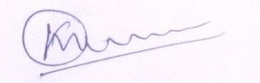

17th July 2024

(Kamakhya Kumar)

Chief Editor

# Contents

Editor’s Note 117

1. Association between cognitive flexibility and flourishing in patients with chronic non-communicable illnesses and healthy individuals

Kumari Prasoon et.al 119-127

1. Impact of Yogic practices on General intelligence and General-well-being Of School going children

Dr Kamakhya Kumar 128-132

1. To Study The Effect Of Yoga On Hba1c, Serum Insulin Level And Lipid Profile In Diabetic Patients In A Tertiary Care Centre

Dr Rachna Semwal et.al 133-142

1. Impact of yoga therapy on homocysteine levels with distended superficial veins among middle aged Men diagnosed with asymptomatic varicosity

K. Badri & Dr. V. Subbulakshmi 143-152

1. Integrated Naturopathy and Yoga Management (INYM) of Obesity: A Single Case Study

Dr. Sushmitha CT & Dr. P Sudhakar Reddy 153-159

1. Impact of pranayama exercises on the quality-of-life perception in students

Ajay Kumar Chaudhary & Alok Kumar 160-167

1. Mind Sound Resonance Technique (MSRT) as a Psychological Treatment and its Impact on Personality Characteristics among Teachers of Special Children: A Pilot Study

Sonali Hadke & Prof. Madhusudan Penna 168-184

1. Yoga for the adjuctive management of chronic low back pain: a clinical review

Neil K. Agarwal, & Shashi K. Agarwal 185-192

1. A yoga module for musicians: compilation and validation

Shirley Telles et.al 193-203

1. Om chanting and meditation as a therapeutic intervention: a systematic review

Shubhi Taneja 204-217

1. Pain self-efficacy in low back pain after yoga - an interventional trial

Dr Shirley Telles et.al 218-226

1. Need and Usefulness of Methods of Chitta-Prasadhan in the Prevention of Mental Problems of Present Life- A Review

Neha Devi & Dr. Suresh Lal Barnwal 227-233

1. Study for positive effects of AUM-chanting on student’s happiness index

Anubha Pundir 234-240

1. Exploring the Efficacy of Yoga in Alleviating Sciatic Pain during Pregnancy: A Comprehensive Review

Prajakta Sharad Kulkarni 241-248

Guidelines 249