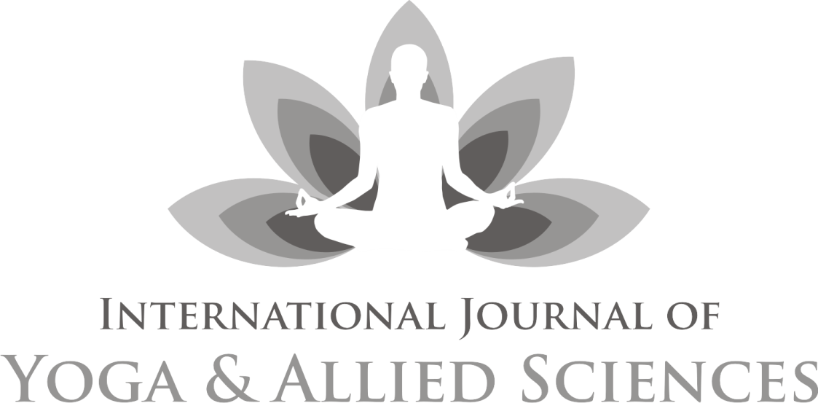
An official publication of Indian Association of Yoga, New Delhi
Double blind peer-reviewed index journal

Chief Editor
Dr Kamakhya Kumar

Published by: Indian Association of Yoga®, New Delhi
www.indianassociationofyoga.org, www.indianyoga.org
International Journal of Yoga and Allied Sciences

Advisory Board:
Dr. Sat Bir Singh Khalsa, PhD, Brigham and Women's Hospital, Boston, USA
Dr. S P Mishra, Former Vice Chancellor, Dev Sanskriti Vishwavidyalaya, Haridwar, India
Dr. Vijendra Chauhan, Advisor (Academic), Swami Rama Himalayan University, Dehradun, India
Prof. Ishwar Bharadwaj, Former Dean, Gurukul Kangri University, Haridwar, India
Prof. J P N Mishra, Former Dean, Faculty of Life Sciences, Central University of Gujrat, Gandhinagar, Gujrat. India
Prof. B R Sharma, Vice Chancellor, Sri Sri University, Cuttack, India
Mrs. Meera Sharma, Director, Centre for Spiritual &Transpersonal Studies, London, U K.
Review Committee:
Prof. V K Katiyar, Former Head Dept. of Mathmatics and Nano Technology, I I T Roorkee. U.K India
David Shannahoff-Khalsa, University of California, San Diego (BCI) California, United States
Dr Latha Satish, Managing Trustee, Krishnamachari Yoga Mandiram, Chennai, Tamilnadu, India
Dr S K Ganguly Principal (Retd.), G.S. College of Yoga & C.S., Kaivalyadhama, Lonavla, Maha, India
Dr N B Shukla, Prof. Physical Education, Banaras Hindu University, Varanashi, U.P India
Dr Barbara Prudhomme White, College of Health and Human Services, University of New Hampshire, Durham, USA
Dr K Krishna Sharma, Chairman, Dept. of Human Cons. & Yogic Science, Manglore Univ. Karnataka India
Dr Babulal Dayma, Chairman, Yoga Center, Jai Narayan Vyas University Jodhpur. Raj. India
Dr D S Baghel, Director, Institute of Yoga, Magadh University, Bodh Gaya. Bihar, India
Dr Biman Pal, Head Dept. of Yoga, Gujrat Vidyapeeth, Ahmedabad.Gujrat India
Mr Sukhdeo Jangid, Health House, Sidcup, Greater London, United Kingdom
Editorial Board:
Dr Ajay Bharadwaj, India
Mrs Pratibha Kumari, India
Dr. Shudhanshu Verma, India
Dr Anupam Kothari, India
Mr Simon C Parish, Germany
Editor’s Note
O’h God! Thou art the Giver of Life,
Remover of pain and sorrow,
The Bestower of happiness,
O’h Creator of the Universe,
May we receive thy supreme sin-destroying light,
May Thou guide our intellect in the right direction.
Hari Om!
I am delighted to bring the current volume of IJOYAS on the opening of a mega event. It is a privilege to release this issue on the inauguration of Scientific exploration of principles & practices of Yoga, jointly organized by Dept of Yogic Science, Uttarakhand Sanskrit University, Haridwar and Indian Association of Yoga, New Delhi.
Readers might be aware that IJOYAS completed its six years of publication successfully. During this period we tried to provide a really exciting opportunity to consider the truly interdisciplinary nature of Yoga and studies going on all over.
The objective of this journal is to publish up-to-date, high-quality and original research papers alongside relevant and insightful reviews. It includes technical and professional aspects of Yoga and allied disciplines like Philosophy, Spirituality, Psychology, Human Consciousness, Medical, Paramedical sciences, Health sciences, Therapy, Education, Physical education, exercise and sports sciences, biomechanics, Literary/textual studies, Physiology, Biochemistry etc.
My sincere thanks to all the member of advisory and review committee, for their effort and contributors to this issue. Needless to say, any papers that you wish to submit, either individually or collaboratively, are much appreciated and will make a substantial contribution to the development and success of the journal.
Best wishes and thank you in advance for your contribution to the Journal. May God give us success; May the Almighty illuminate our intellect to lead us along the righteous path.
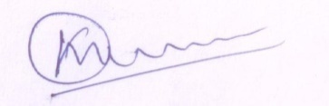
(Kamakhya Kumar)
Chief Editor
24th FEB 2024
Contents
Editor’s Note 03

- To Study The Effect Of Yoga On Hba1c, Serum Insulin Level And Lipid
Profile In Diabetic Patients In A Tertiary
Care Centre
Dr Rachna Semwa & et.al 16-24

- Effectiveness Of Pranayama On Sustained Attention Among Adolescents
Mutalikadesai S & et.al 25-30

- Effect Of Yogic Practices On Selected Physiological Variables Among Middle
Aged Hypertensive Women
Satyaki Chakraborty & Mainak Chakraborty 31-39

- Playing Around Nature: Effect On Working Memory Of Preschoolers
Dr. Shivanidr & Sona Ahuja 40-48

- Effect Of Practicing Yoga Versus Reading Books On Better Sleep Quality In
Senior Citizens Residing In An Old Age Home
Priyanshi Kaushik & Abhishek K. Bhardwaj 49-58

- Modified Yoga On Facilitation Of Motor Function For Persons Having Multiple
Disabilities (Cerebral Palsy With Intellectual Disability)
Dr. A. Amarnath & K.Swathini 59-64

- Systematic Review Of Systematic Reviews Of Yoga Compared To Active
Interventions For Chronic Low Back Pain
Dipak Chetry & et.al 65-83
- An Analytical Study Of The Science And Philosophy Of Mantra Yoga
Dr. Ajay Bhardwaj 84-98
- Diet Management In Hathayoga Tradition For Well-Bieng
Mr. Raghu H Megalamani & et.al 99-103

- Yoga As An Effective Complementary Approach In Managing Unexplained
Female Infertility
Dr.Manisha Thakare & et.al 104-108
- Sudarshan Kriya: A Boon To Mankind
Pramod, J.P. & Vanita Malewar 109-113

Guidelines 114

