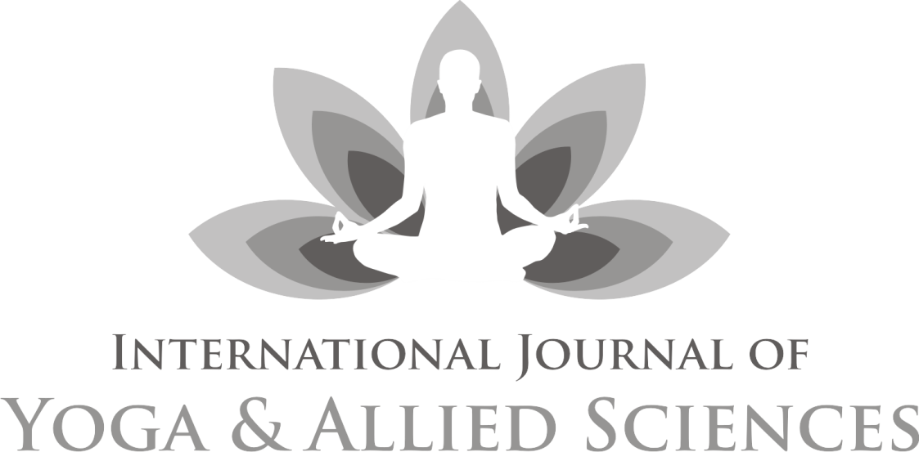
An official publication of Indian Association of Yoga, New Delhi
Double blind peer-reviewed index journal

Chief Editor
Dr Kamakhya Kumar

Published by: Indian Association of Yoga®, New Delhi
www.indianassociationofyoga.org, www.indianyoga.org
International Journal of Yoga and Allied Sciences

Advisory Board
Dr. Sat Bir Singh Khalsa, PhD, Brigham and Women's Hospital, Boston, USA
Dr. S P Mishra, Ex Vice Chancellor, Dev Sanskriti Vishwavidyalaya, Haridwar, India
Dr. Vijendra Chauhan, Advisor (Academic), Swami Rama Himalayan University, Dehradun, India
Prof. Ishwar Bharadwaj, Head, Dept. of Yogic Science, Gurukul Kangri University, Haridwar, India
Prof. J P N Mishra, Dean, Dept. of Life Sciences, Central University of Gujrat, Gandhinagar, Gujrat. India
Prof. B R Sharma, Principal, Kaivalyadham Yoga Institute, Kaivalyadhama, Lonavla, Maharastra, India
Mrs. Meera Sharma, Director, Centre for Spiritual &Transpersonal Studies, London, U K.

Review Committee
Prof. V K Katiyar, Dept. of Mathmatics and Nano Technology, I I T Roorkee. U.K India
David Shannahoff-Khalsa, University of California, San Diego (BCI) California, United States
Prof. J P N Mishra, Head Dept. of SOL, PM & Yoga, Jain Vishwa Bharati Univ. Raj. India
Dr Latha Satish, Managing Trustee, Krishnamachari Yoga Mandiram, Chennai, Tamilnadu, India
Dr S K Ganguly Principal (Retd.), G.S. College of Yoga & C.S., Kaivalyadhama, Lonavla, Maha, India
Dr. B R Sharma, , Principal, Kaivalyadham Yoga Institute, Kaivalyadhama, Lonavla, Maharastra, India
Dr N B Shukla, Prof. Physical Education, Banaras Hindu University, Varanashi, U.P India

Associate Editors
Dr Latha Satish, Managing Trustee, Krishnamachari Yoga Mandiram, Chennai, Tamilnadu, India
Dr Barbara Prudhomme White, College of Health and Human Services, University of New Hampshire, Durham, USA
Dr K Krishna Sharma, Chairman, Dept. of Human Cons. & Yogic Science, Manglore Univ. Karnataka India
Dr Babulal Dayma, Chairman, Yoga Center, Jai Narayan Vyas University Jodhpur. Raj. India
Dr D S Baghel, Director, Institute of Yoga, Magadh University, Bodh Gaya. Bihar, India
Dr Biman Pal, Head Dept. of Yoga, Gujrat Vidyapeeth, Ahmedabad.Gujrat India
Mr Sukhdeo Jangid, Health House, Sidcup, Greater London, United Kingdom

Editorial Board
Dr Vinod D Deshmukh, MD, Florida, USA
Dr Ajay Bharadwaj, India
Dr. Abhishek Bharadwaj
Mrs Pratibha Kumari, India
Mr Simon C Parish, Germany
Editor’s Note
O’h God! Thou art the Giver of Life,
Remover of pain and sorrow,
The Bestower of happiness,
O’h Creator of the Universe,
May we receive thy supreme sin-destroying light,
May Thou guide our intellect in the right direction.
Hari Om!
I am delighted to bring the current volume of IJOYAS on the opening of a mega event. It is a privilege to release this issue on the inauguration of Yoga in Synergy with Science, jointly organized by Dept of Yogic Science, Uttarakhand Sanskrit University, Haridwar and Indian Association of Yoga, New Delhi.
Readers might be aware that IJOYAS completed its six years of publication successfully. During this period we tried to provide a really exciting opportunity to consider the truly interdisciplinary nature of Yoga and studies going on all over.
The objective of this journal is to publish up-to-date, high-quality and original research papers alongside relevant and insightful reviews. It includes technical and professional aspects of Yoga and allied disciplines like Philosophy, Spirituality, Psychology, Human Consciousness, Medical, Paramedical sciences, Health sciences, Therapy, Education, Physical education, exercise and sports sciences, biomechanics, Literary/textual studies, Physiology, Biochemistry etc.
My sincere thanks to all the member of advisory and review committee, for their effort and contributors to this issue. Needless to say, any papers that you wish to submit, either individually or collaboratively, are much appreciated and will make a substantial contribution to the development and success of the journal.
Best wishes and thank you in advance for your contribution to the Journal. May God give us success; May the Almighty illuminate our intellect to lead us along the righteous path.
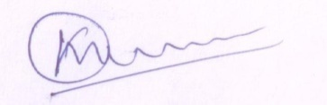
(Kamakhya Kumar)
Chief Editor
25th FEB 2023
Contents
Editor’s Note 03

1. Therapeutic Applications Of Yoga To Reduce Weight And To Improve
Lipid Profile In Overweight Women Paricipants
Dr. Rangappa, Dr. Rashmitha & Dr. K. Krishna Sharma 5-12
2. An experimental study of the effects on participants of the one-week
Ashram based YPV Arhat Yoga Intensive Program on their BMI, energy
and stress levels, brain wave activity and heart rate variability (HRV)
Neravetla Jayachander Reddy & et.al 13-30

3. Effectiveness Of Yoga Therapy On Socio-Adaptive Functioning And Oral Health
Among Students Diagnosed With Multiple Disabilities – An Interventional
Study
Selva Mani S & et.al 31-41

4. Review Analysis on Yoga as an Intervention on Students Stress and Anxiety
Levels in School Settings
Raja Santosh Kumar Mohapatra & Dr. Vijendra Prakash Kapruwan 42-59

5. A holistic approach of Yoga and Ayurveda for Covid-19
Prof. Mahesh Prashad Silori & et.al 60-69

6. Effects of Detoxification methods (ShatKriya) on mental health
Dr. Laxmi Gupta Yogacharya & Anjali Prabhakar 70-74

7. Role of asanas as a preventive as well as curative measure for postural
defects and related musculoskeletal disorders
Dr. Parinita Singh 75-81

8. Impact of Hatha Yoga on Suicidal Ideation among Transgender People
Ashish & Narendra Kumar Sharma 82-87

9. Safety And Efficiently Pain Management Through Alternative Therapy
(Yoga & Naturopathy)
Dr. Meena Kumari Sethi 88-96

10. Benefits of Integrated Yoga Practice for Destitute Elderly Widows in Vrindavan
Jyoti Varshney & Prof. Madhusudan Penna 97-100

11. Impact of Yoga-based lifestyle on Lipid profile level in Dyslipidaemia with Prehypertension
Rajkumar Sharma & et.al 101-108

12. Effect of Yoga and Physical exercise in Ophthalmology
Dr. Bharti Nigam & Dr. Deeksha Tyagi 109-114

Guidelines 115

